**Project Title --Developing a Backend Admin for Learner’s Academy.**

**By Dr. Jyothi N.M.**

**Git link**

[**https://github.com/jyothiarunkr/Phase2-Project-Learners-Academy.git**](https://github.com/jyothiarunkr/Phase2-Project-Learners-Academy.git)

**Step by step Screen shots of the Project**

**1.Management of Teachers List**

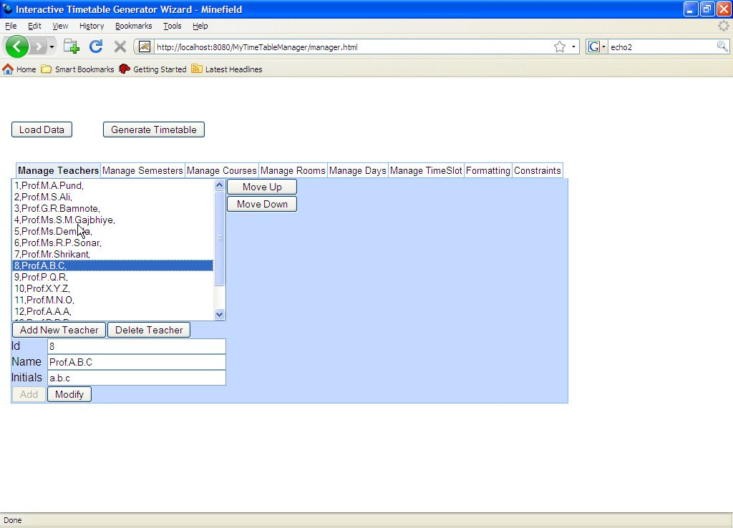

**2.Management of semester list**

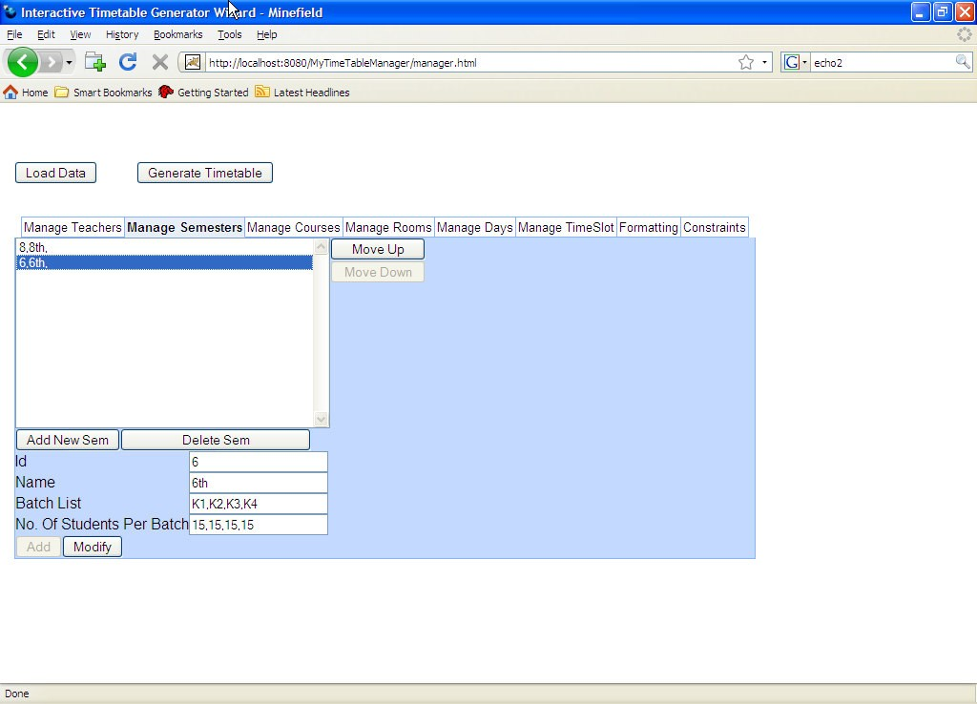

**3.Management of Course List**

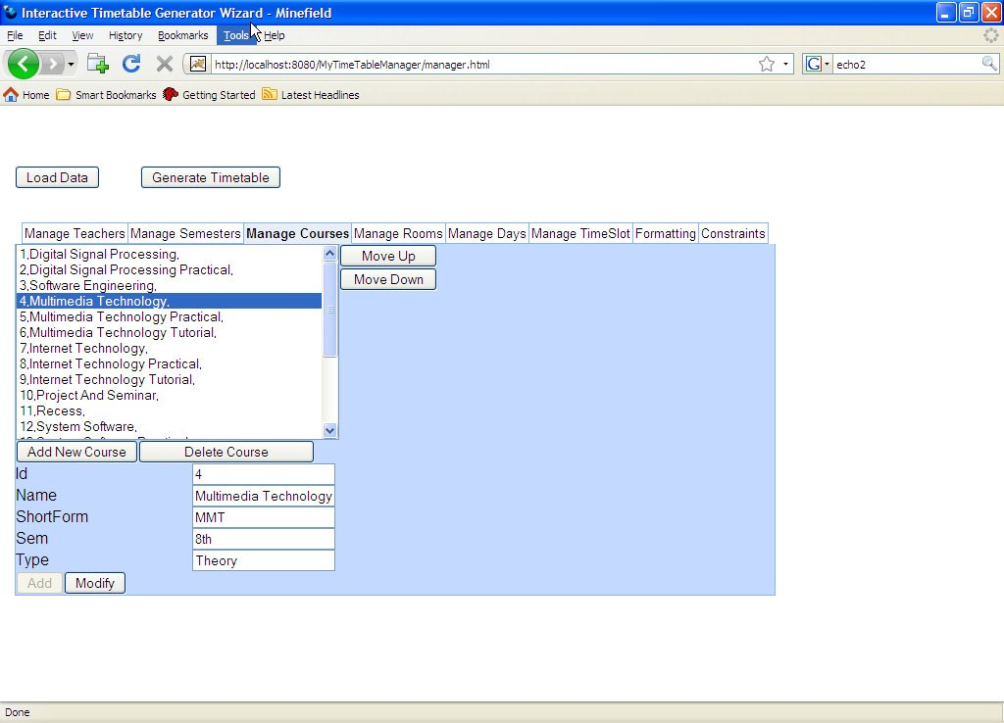

**4.Management of different rooms**

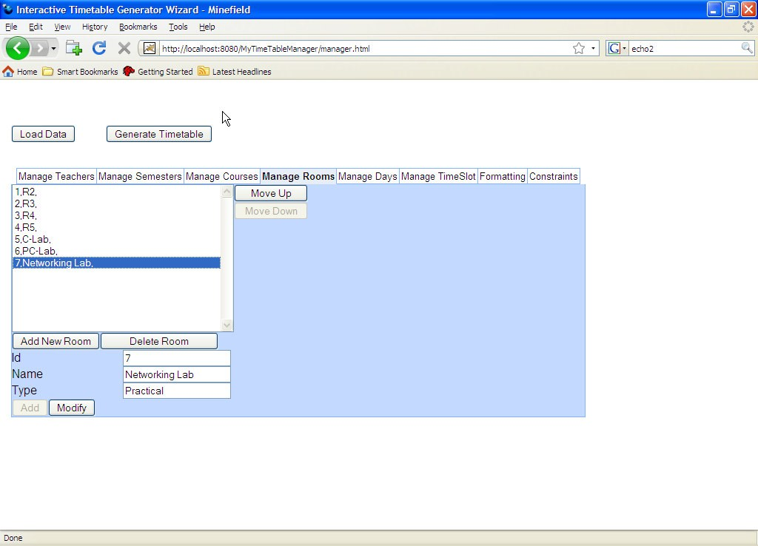

**5.Management of days**

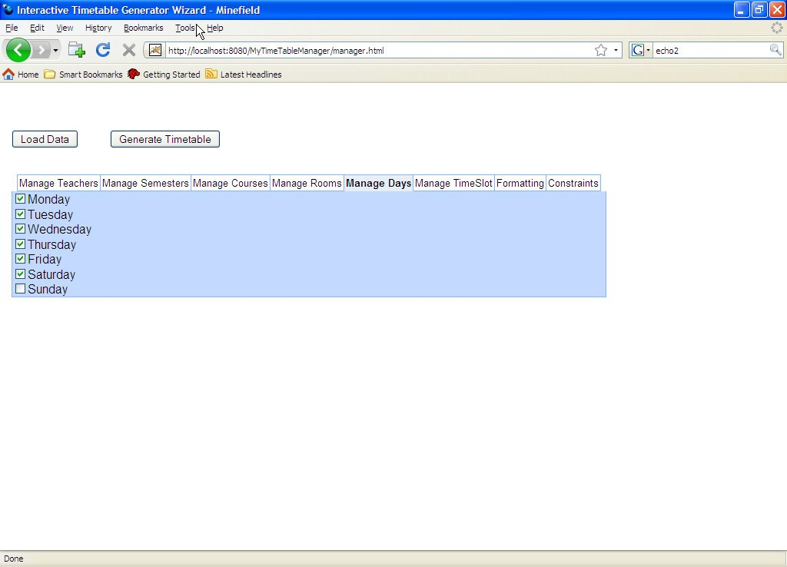

**6.Management of Time Slot**

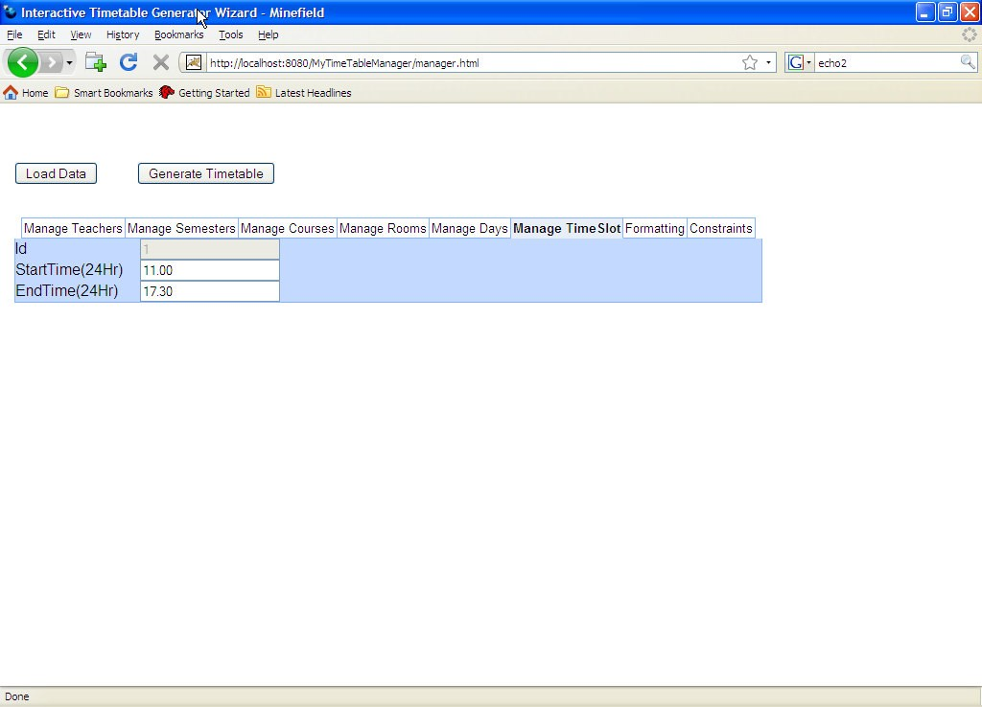

**7.Management of formatting Elements**

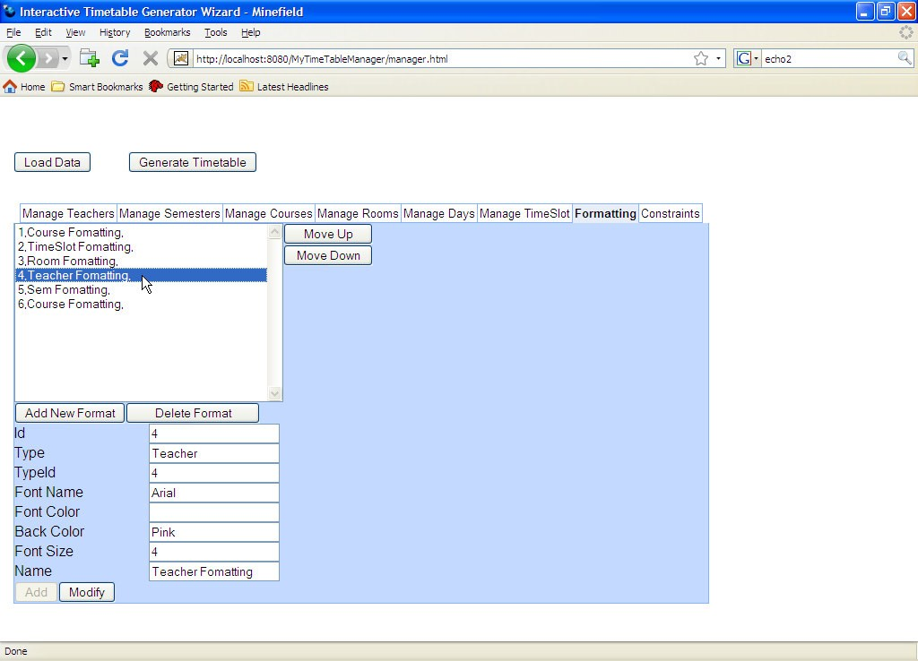

**8.Management of different rules, constraints while generation of Timetable**

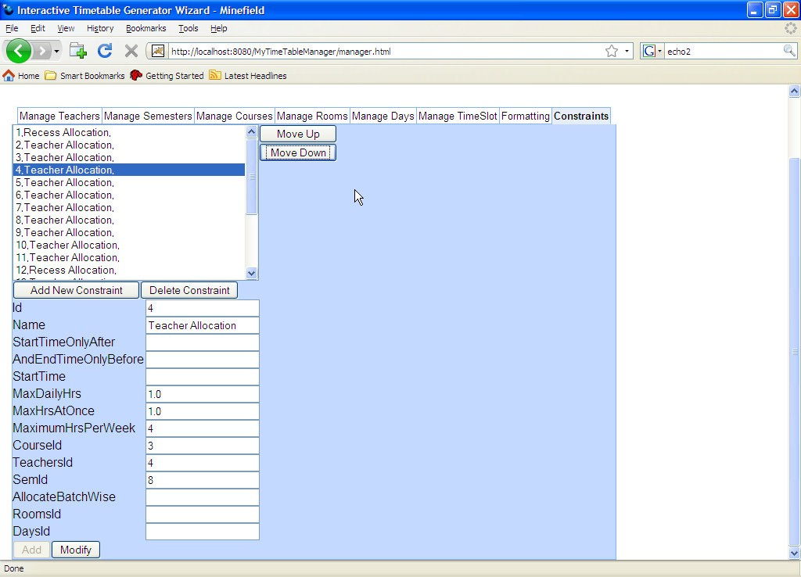

**Click on load data and then on Generate TimTable**

**9. Template of the Empty TimeTable before Generation**

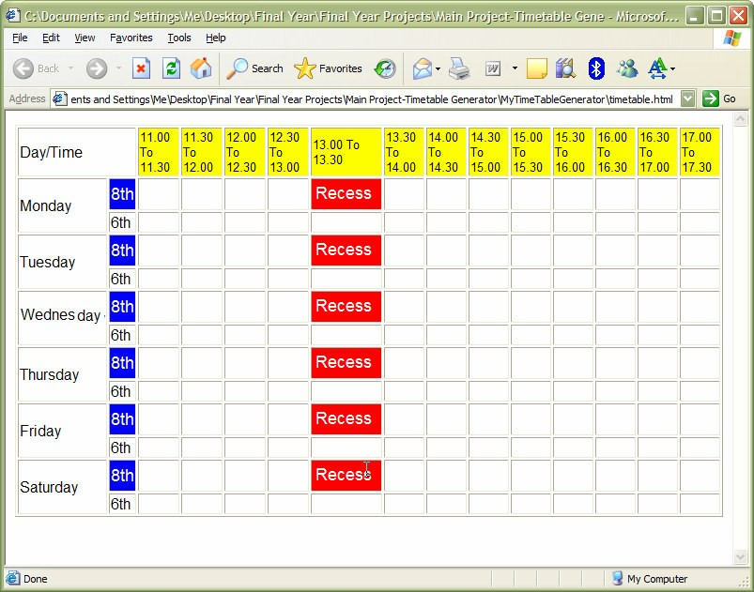

**10.Final time table generated for the above selected elements and downloaded in destination directory**

